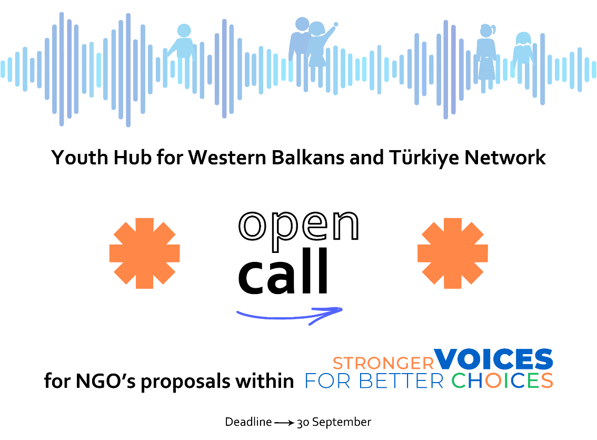

**dESCRIPTION OF THE network**

Youth Hub for Western Balkans and Türkiye Network (further Network), initially founded in 2016, is a network of currently 68 youth and for youth organizations from Western Balkans and Türkiye, whose objective is to ensure greater involvement of young people in Albania, Bosnia and Herzegovina, Kosovo⃰, Montenegro, North Macedonia, Serbia and Türkiye. Network collects data on youth position, monitor and follow the involvement of youth in all countries. It supports youth policy changes to achieve higher participation of young people in political, economic and social life in each country.

**DESCRIPTION OF THE PROJECT**

According to Eurostat, the total youth population in the WB6 is over 3,6 million (21.27% of the total population), while the youth population in Türkiye is 12 million (15.2% of the total population). Countries covered by the Project are struggling with the EU approximation process, fragile democratic institutions, human rights violations, media freedom and pluralism, and a huge (particularly youth) emigration to EU and other countries. Although young people constitute such a huge % of population and are crucial for the present and the future of the WB&T region, their participation in the above listed developments, and consequently the influence in the transition societies remains sideways and inadequate. In some areas and countries, the youth support system is partially working, but tends to benefit youth that are already active or/and engaged, leaving the majority of young people left behind the opportunities, information, knowledge and skills, particularly young women and marginalized youth. These young people face unique challenges and barriers, including a lack of quality jobs, inadequate education opportunities, a high risk of poverty, and exclusions with the absence of political representatives who would advocate on their behalf.

[2023 Youth Participation Index](https://youthwbt.eu/wp-content/uploads/2025/04/YPI-2023-Report.pdf) (YPI) published by the Network, highlights persistent youth underrepresentation in political life (particularly women), exclusion from employment and education, and a high risk of poverty. Index provided gender data/analyses for several indicators, showing that significant gender gaps in all countries, particular when it comes to labour activity, NEET[1] rates, and in women entrepreneurship. The Project is in line with the Council of Europe 2022 statement on protecting civil society and young people, highlighting “*the importance of the genuine and meaningful participation of young people in democratic life, in particular through youth civil society, for building more democratic, peaceful and inclusive societies*.”

Key Project objectives are:

! To provide evidence-based advocacy for improved policymaking and reform process implementation,

! To increase capacities and regional collaboration of NGOs to influence decision-making and societal debate, particularly on young women and men, via Youth Hub for WB&T Network

! To increase engagement, visibility and influence of NGOs in raising public awareness, mobilizing citizens and promoting broadest civic participation.

**call for NGOs project proposals**

We invite mostly small and medium local non-governmental organizations which have an innovative idea, who are committed and actively involved in increase of youth participation, especially under-represented and vulnerable groups of youth (to name some: young women and girls, Roma youth, youth with disabilities, NEET youth, etc.) to apply to this Call for Proposals.

The main goal of this Call is to strengthen the current Network member’s capacities to keep contributing to process of improving the position of youth (LOT 1) and to expend the Network in order to enable pathway for smaller, local CSOs to directly engage in different activities on local, national and regional level regarding increase of systematic and meaningful youth participation (LOT 2). The decision is based on the commitment for keeping continuity of work of local NGOs necessary in order to align processes on national and local level and increase the adequate response to challenges that youth are faced with (especially vulnerable, under-represented ones). **This is the regional Call for proposals that will be announced and operationalized simultaneously, but separately in each Project country. In Türkiye it is implemented by Community Volunteers Foundation (TOG)**

**Size of Sub-Grant**: Any grant requested under this call for proposals must fall between the following Any grant requested under this call for proposals must be in the up to following amounts:

**LOT 1:** Maximum project amount: EUR 8,000 per grant. This amount includes the co-finance from the grant applicants. The grant from the Contracting Authority may cover a maximum of 90% of the total eligible costs of the project. The rest of 10% needs to be covered by selected organizations from sources other than the general budget of the European Union or the European Development Fund.

**LOT 2:** Maximum project amount: EUR 5,000 per grant. This amount includes the co-finance from the grant applicants. The grant from the Contracting Authority may cover a maximum of 90% of the total eligible costs of the project. The rest of 10% needs to be covered by selected organizations from sources other than the general budget of the European Union or the European Development Fund sources.

**Duration:** The duration of the project awarded under this call for proposals may not be less than **6 months** nor exceed **12 months.**

**Location:** Actions must take place across Türkiye

Beside financial support, selected applicants will participate in the in - person and online country-specific and regional trainings on different topics, including the financial and operational management of EU funded projects, as well as mentoring support. The mentoring support will include regular mentoring sessions of the youth and for youth NGOs representatives with the national hubs and annual network meeting at the national level in the course of development of their inovative solutions, and in the course of its implementation.

**Aplication procedure**

* The call is opened to all interested NGOs operating in local communities in the field of youth (especially the one coming from marginalized groups) and socio-economic issues;
* Deadline for the submission of the applications is **September 30th, 2025, until 16.00 (CEST).** Applications need to be sent to: yasin.bulat@tog.org.tr
* Questions regarding application process may be sent by e-mail no later **than September 15th 2025, until 10 a.m.**  to the following address: yasin.bulat@tog.org.tr indicating clearly the reference of the Call for Proposals.
* Info session for interested candidates will be organized not later than 15 days before the submission deadline (STAY TUNED).
* The selection of applicants will be competitive and based on the information provided in the application form.

**Below you will find all the necessary information within the Guidelines for applicants. Within the Guidelines you will find the complete application package.**

**DOCUMENT FOR INFORMATION**

Guidelines for applicants **–** [**https://www.tog.org.tr/employouth-yerel-stklar-icin-kapasite-gelistirme-programi**](https://www.tog.org.tr/employouth-yerel-stklar-icin-kapasite-gelistirme-programi)

1. Not in Education, Employment, or Training